<https://www.youtube.com/watch?v=MHtebyNxo0A>

[13:36](https://www.youtube.com/watch?v=MHtebyNxo0A)

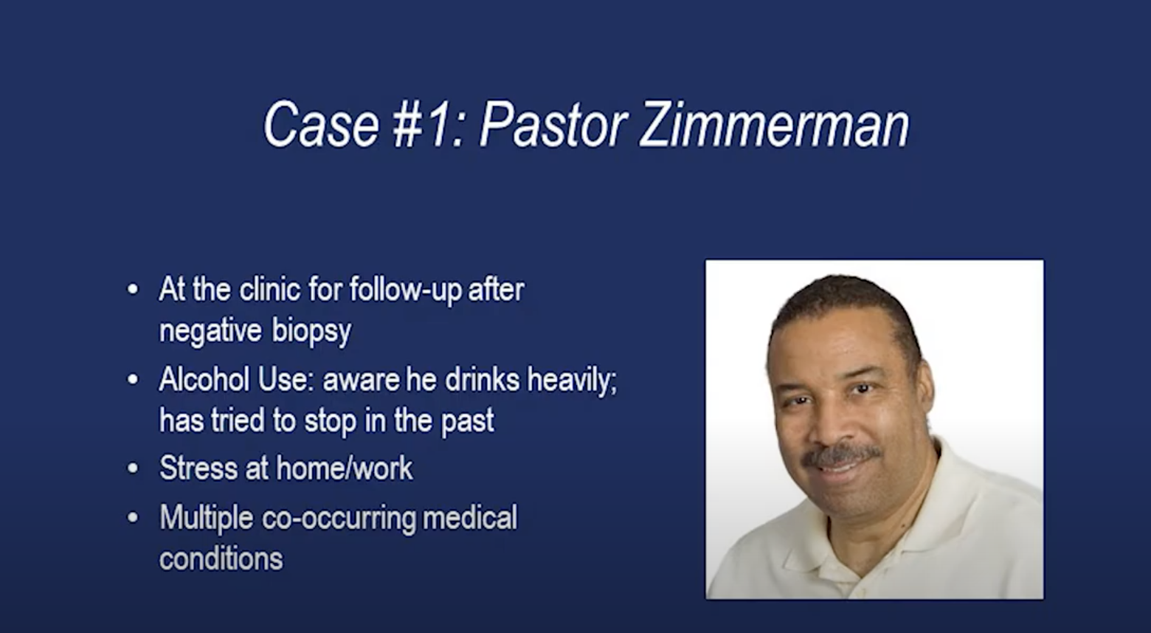

Medical data?

Hi pastor Zimmerman. My name is Branden Kay. I am a nurse practitioner student. I will be working with you today.

* Ok

I understand you were here because you had a nodule removed in your throat. Is that correct?

* Yes, maam.

Okay. Do you mind just telling me a little bit about yourself?

* Well. I've been pastoring the church for the last 25 years and I have built up a nice congregation. My wife's at home with Alzheimer's. I feel very guilty these days because I've been drinking pretty heavily and I don't want to disappoint people. But it’s the only way I’ve been able to cope lately.

Okay. Can you tell me a little bit more about your wife?

* It's not an easy situation. She has good days and bad days. And on the bad days, I get affected the most. You know my son helps a lot around the house but he is working on his PhD. and he doesn’t have time to help me out that much. It's just very painful to watch it deteriorate and the drinking helps me cope.

That sounds like it would be incredibly hard. So it sounds like you are using alcohol as a coping mechanism.

* Yes, there is nothing I am proud of.

Okay, you completed the audit, it's an alcohol use assessment today. We give it to all of our patients. Is it ok if I go over it with you?

* Sure.

Okay you scored a 16 which means you are drinking it at risk levels and I understand it is something that you are using to cope with a lot going on at home. But I just wanted to give you some feedback on that.

Obviously there are good and bad things about your drinking. Are you able to name some of the benefits you get?

* t calms me down, helps me sleep, and makes it easier for me to communicate with people.I
* I know it's not healthy for me but it's the most cost-efficient way for me to calm down these days.

Okay, can you name some of theinate the shots and drink only beer?

* Yes, that might be a good way of trying to wean myself off the heavy stuff.

How much beer are you drinking?

About two to three 12-o negatives as well?

* Well what happened with my throat is one thing. I also could lose face with people that put a lot of faith in me. Overall, it is just not good for my health.

Have you ever tried to cut back in the past?

* You know I've been successful sometimes.
* I can cut back to two or three beers a day but then something will always come up to trigger it again.
* You know something will happen at church, I have a problem with trying to communicate with my wife, or something in the family.

What has worked in the past when you’ve cut back on your use

* When I focus on trying to exercise more, when I meet with friends but I don't have a lot of time to do that with my current situation. That’s why I could never get any consistent with any of that.

It sounds to me like when you use other coping mechanisms you’ve been more successful in cutting back on your alcohol use. But right now you have a lot going on with your wife.

Have you thought about an Alzheimer’s support group or something that could help you have a circle that could help you with what you are dealing with your wife?

* No I haven't. That's a good idea. I know I can join Alcohols and Anonymous. Sometimes my wife's situation could be beneficial.

Now I have one other question. We did talk about your alcohol use. Do you feel willing to cut back right now on a scale of one to ten how willing you would say that you are?

* Oh at least an eight.

How confident are you that you would be able to do that?

* That’s probably about six or seven. It’s because I haven’t been successful in maintaining it in the past.

Okey. so it sounds like there is a little bit of discrepancy between your willingness and your confidence. Maybe we can come up with some solutions together. Would you be ok with talking about that?

* That would be great.

Okay, so maybe instead of cutting out alcohol altogether you could cut back at first. How much are you drinking when you are drinking alcohol?

Two or three beers a night with a couple of shots.

Would you be willing to first elimunce.

So maybe if we can drink two 12-ounces a night at first to cut back and then slowly see how that goes.

What about some exercise? Did it work for you in the past to help with your stress?

* Back in the day I used to swim every day.
* That was very relaxing.
* But I can't take advantage of it. You know with my current situation if I could just find some way to do it regularly, I think it will help.

Yes, maybe even some in-home exercise would help a little bit with your stress relief. It sounds like you are willing to work on this. Maybe I can talk to you about this again at the next visit?

* Yeah sure.

Okay great. It was nice meeting you and nice talking to you.

* Thank you